Week 2 Day 1 Classroom Task
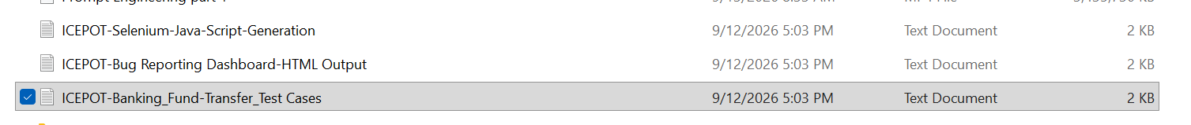
TC ID | Priority | Description | Precondition | Steps | Expected / Actual Result | Test Data
TC001 | P0 | Verify successful fund transfer between two active accounts within the same bank | Source and destination accounts are active; source has sufficient balance | 1. Log in2. Navigate to Fund Transfer3. Enter valid destination account4. Enter valid amount5. Submit transfer6. Confirm transaction | Expected: Transfer succeeds; source account is debited and destination account is credited correctly.Actual: To be captured during execution. | Source: 445556Destination: 434343Amount: $1,000
TC002 | P0 | Verify fund transfer is rejected when source account has insufficient balance | Source account is active with insufficient available balance | 1. Log in2. Navigate to Fund Transfer3. Enter valid destination account4. Enter amount greater than available balance5. Submit | Expected: Transfer is rejected with an insufficient-funds message; neither account balance is incorrectly updated.Actual: To be captured during execution. | Source Balance: $500Destination: 434343Amount: $1,000
TC003 | P0 | Verify fund transfer is rejected for an invalid destination account | Source account is active and has sufficient balance | 1. Log in2. Navigate to Fund Transfer3. Enter an invalid/non-existent destination account4. Enter valid amount5. Submit | Expected: Transfer is rejected with destination-account validation; source account is not debited.Actual: To be captured during execution. | Source: 445556Destination: InvalidAmount: $500
TC004 | P1 | Verify fund transfer succeeds for the minimum permitted amount | Both accounts are active; source has sufficient balance; minimum transfer limit is configured | 1. Log in2. Navigate to Fund Transfer3. Enter valid destination account4. Enter the minimum permitted amount5. Submit | Expected: Transfer succeeds and balances are updated by the exact transfer amount.Actual: To be captured during execution. | Destination: 434343Amount: Configured minimum
TC005 | P1 | Verify fund transfer is rejected when amount exceeds the configured transaction limit | Both accounts are active; source has sufficient balance; transaction limit is configured | 1. Log in2. Navigate to Fund Transfer3. Enter valid destination account4. Enter amount exceeding the configured limit5. Submit | Expected: Transfer is rejected with an appropriate limit-validation message; balances remain unchanged.Actual: To be captured during execution. | Destination: 434343Amount: Above configured limit
TC006 | P1 | Verify fund transfer is rejected when amount is zero | Both accounts are active | 1. Log in2. Navigate to Fund Transfer3. Enter valid destination account4. Enter $0 as transfer amount5. Submit | Expected: Transfer is rejected with amount-validation feedback; no transaction is created.Actual: To be captured during execution. | Destination: 434343Amount: $0
TC007 | P1 | Verify fund transfer is rejected when amount is negative | Both accounts are active | 1. Log in2. Navigate to Fund Transfer3. Enter valid destination account4. Enter a negative transfer amount5. Submit | Expected: Negative amount is rejected; no transaction is processed and balances remain unchanged.Actual: To be captured during execution. | Destination: 434343Amount: -$100
TC008 | P2 | Verify successful transfer between two accounts owned by the same customer | Customer owns two active accounts within the bank; source has sufficient balance | 1. Log in2. Navigate to Fund Transfer3. Select the customer's destination account4. Enter valid amount5. Submit | Expected: Transfer succeeds and the correct source and destination accounts are updated.Actual: To be captured during execution. | Source: Customer Account ADestination: Customer Account BAmount: $250
TC009 | P2 | Verify transfer is rejected when destination account is not provided | Source account is active and has sufficient balance | 1. Log in2. Navigate to Fund Transfer3. Leave destination account blank4. Enter valid amount5. Submit | Expected: Transfer is not processed and mandatory destination-account validation is displayed.Actual: To be captured during execution. | Destination: BlankAmount: $500
TC010 | P2 | Verify transfer is rejected when transfer amount is not provided | Source and destination accounts are active | 1. Log in2. Navigate to Fund Transfer3. Enter valid destination account4. Leave transfer amount blank5. Submit | Expected: Transfer is not processed and mandatory amount validation is displayed.Actual: To be captured during execution. | Destination: 434343Amount: Blank

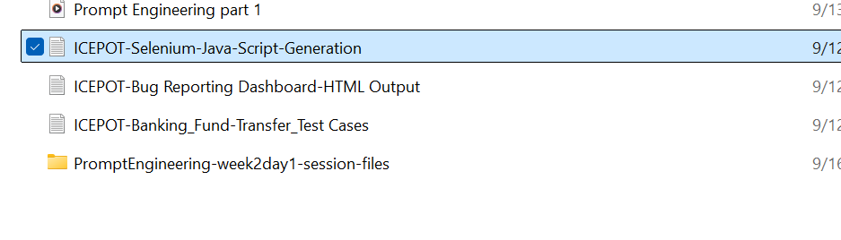
package com.example.pages;

import org.openqa.selenium.By;
import org.openqa.selenium.WebDriver;
import org.openqa.selenium.WebElement;
import org.openqa.selenium.support.ui.ExpectedConditions;
import org.openqa.selenium.support.ui.WebDriverWait;

import java.time.Duration;

/**
* Page Object representing the e-commerce application's login page.
*
* <p>Encapsulates login-page locators and user interactions to keep
* test logic independent of page implementation details.</p>
*/
public class LoginPage {

private final WebDriver driver;
private final WebDriverWait wait;

private final By usernameField =
By.xpath("//input[@name='username']");

private final By passwordField =
By.xpath("//input[@name='password']");

private final By rememberMeCheckbox =
By.xpath("//input[@type='checkbox' and @name='rememberMe']");

private final By loginButton =
By.xpath("//button[normalize-space()='Login']");

private final By forgotPasswordLink =
By.xpath("//a[normalize-space()='Forgot password']");

private final By loginErrorMessage =
By.xpath("//*[contains(@class,'error') or @role='alert']");

private final By welcomeBanner =
By.xpath("//*[contains(@class,'welcome') or contains(@class,'banner')]");

/**
* Creates the LoginPage object and initializes the explicit wait.
*
* @param driver WebDriver instance used by the page object
*/
public LoginPage(WebDriver driver) {
this.driver = driver;
this.wait = new WebDriverWait(driver, Duration.ofSeconds(10));
}

/**
* Opens the application's login page.
*
* @param applicationUrl URL of the application login page
*/
public void open(String applicationUrl) {
driver.get(applicationUrl);

wait.until(
ExpectedConditions.visibilityOfElementLocated(usernameField)
);
}

/**
* Enters a username into the username field.
*
* @param username username to enter
*/
public void enterUsername(String username) {
WebElement element = wait.until(
ExpectedConditions.elementToBeClickable(usernameField)
);

element.clear();
element.sendKeys(username);
}

/**
* Enters a password into the password field.
*
* @param password password to enter
*/
public void enterPassword(String password) {
WebElement element = wait.until(
ExpectedConditions.elementToBeClickable(passwordField)
);

element.clear();
element.sendKeys(password);
}

/**
* Selects the Remember Me checkbox when it is not already selected.
*/
public void selectRememberMe() {
WebElement checkbox = wait.until(
ExpectedConditions.elementToBeClickable(rememberMeCheckbox)
);

if (!checkbox.isSelected()) {
checkbox.click();
}
}

/**
* Clicks the Login button.
*/
public void clickLogin() {
wait.until(
ExpectedConditions.elementToBeClickable(loginButton)
).click();
}

/**
* Performs login using the supplied credentials.
*
* @param username username to authenticate with
* @param password password to authenticate with
*/
public void login(String username, String password) {
enterUsername(username);
enterPassword(password);
clickLogin();
}

/**
* Returns the current browser URL.
*
* @return current URL
*/
public String getCurrentUrl() {
return driver.getCurrentUrl();
}

/**
* Returns the welcome banner text after successful authentication.
*
* @return welcome banner text
*/
public String getWelcomeBannerText() {
return wait.until(
ExpectedConditions.visibilityOfElementLocated(welcomeBanner)
).getText();
}

/**
* Returns the login error message displayed after an unsuccessful login.
*
* @return error message text
*/
public String getLoginErrorMessage() {
return wait.until(
ExpectedConditions.visibilityOfElementLocated(loginErrorMessage)
).getText();
}

/**
* Determines whether the Remember Me checkbox is selected.
*
* @return true when selected; otherwise false
*/
public boolean isRememberMeSelected() {
return wait.until(
ExpectedConditions.visibilityOfElementLocated(rememberMeCheckbox)
).isSelected();
}

/**
* Determines whether the Forgot Password link is displayed.
*
* @return true when displayed; otherwise false
*/
public boolean isForgotPasswordLinkDisplayed() {
return wait.until(
ExpectedConditions.visibilityOfElementLocated(forgotPasswordLink)
).isDisplayed();
}
}

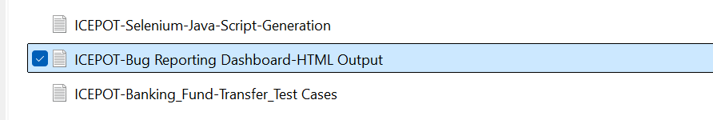
<!DOCTYPE html>
<html lang="en">
<head>
<meta charset="UTF-8">
<meta name="viewport" content="width=device-width, initial-scale=1.0">
<title>QA Bug Reporting Dashboard</title>

<style>
* {
box-sizing: border-box;
}

body {
margin: 0;
font-family: Arial, Helvetica, sans-serif;
background: #f4f6f8;
color: #1f2937;
}

.dashboard {
max-width: 1440px;
margin: 0 auto;
padding: 24px;
}

.header {
display: flex;
justify-content: space-between;
align-items: center;
gap: 16px;
margin-bottom: 24px;
}

.header h1 {
margin: 0;
font-size: 28px;
}

.header p {
margin: 6px 0 0;
color: #6b7280;
font-size: 14px;
}

.summary-grid {
display: grid;
grid-template-columns: repeat(6, 1fr);
gap: 16px;
margin-bottom: 24px;
}

.card {
background: #ffffff;
border: 1px solid #e5e7eb;
border-radius: 12px;
padding: 20px;
box-shadow: 0 2px 8px rgba(0, 0, 0, 0.04);
}

.card-label {
color: #6b7280;
font-size: 13px;
margin-bottom: 8px;
}

.card-value {
font-size: 28px;
font-weight: 700;
}

.content-grid {
display: grid;
grid-template-columns: 1fr 1fr;
gap: 24px;
margin-bottom: 24px;
}

.section-title {
margin: 0 0 18px;
font-size: 18px;
}

.chart-container {
height: 320px;
position: relative;
}

.legend {
display: grid;
grid-template-columns: repeat(2, 1fr);
gap: 10px;
margin-top: 16px;
}

.legend-item {
display: flex;
align-items: center;
gap: 8px;
font-size: 13px;
}

.legend-dot {
width: 12px;
height: 12px;
border-radius: 50%;
}

.distribution-list {
display: flex;
flex-direction: column;
gap: 16px;
}

.distribution-row {
display: grid;
grid-template-columns: 50px 1fr 45px;
align-items: center;
gap: 10px;
font-size: 13px;
}

.progress {
height: 10px;
background: #e5e7eb;
border-radius: 20px;
overflow: hidden;
}

.progress-bar {
height: 100%;
border-radius: 20px;
}

.table-section {
background: #ffffff;
border: 1px solid #e5e7eb;
border-radius: 12px;
padding: 20px;
box-shadow: 0 2px 8px rgba(0, 0, 0, 0.04);
}

.table-controls {
display: flex;
justify-content: space-between;
gap: 12px;
margin-bottom: 16px;
flex-wrap: wrap;
}

.search-box,
.filter-select {
border: 1px solid #d1d5db;
border-radius: 8px;
padding: 10px 12px;
background: #ffffff;
font-size: 14px;
}

.search-box {
min-width: 260px;
}

.filter-group {
display: flex;
gap: 10px;
flex-wrap: wrap;
}

.table-wrapper {
overflow-x: auto;
}

table {
width: 100%;
border-collapse: collapse;
min-width: 800px;
}

th,
td {
padding: 13px 12px;
border-bottom: 1px solid #e5e7eb;
text-align: left;
font-size: 13px;
}

th {
background: #f9fafb;
color: #374151;
cursor: pointer;
user-select: none;
white-space: nowrap;
}

th:hover {
background: #f3f4f6;
}

tbody tr:hover {
background: #f9fafb;
}

.badge {
display: inline-block;
padding: 5px 9px;
border-radius: 20px;
font-size: 12px;
font-weight: 600;
}

.severity-p0 {
background: #fee2e2;
color: #991b1b;
}

.severity-p1 {
background: #ffedd5;
color: #9a3412;
}

.severity-p2 {
background: #fef3c7;
color: #92400e;
}

.severity-p3 {
background: #dcfce7;
color: #166534;
}

.status-open {
background: #dbeafe;
color: #1e40af;
}

.status-closed {
background: #dcfce7;
color: #166534;
}

.empty-state {
text-align: center;
padding: 32px;
color: #6b7280;
display: none;
}

.footer {
text-align: center;
color: #6b7280;
font-size: 12px;
margin-top: 20px;
}

@media (max-width: 1100px) {
.summary-grid {
grid-template-columns: repeat(3, 1fr);
}

.content-grid {
grid-template-columns: 1fr;
}
}

@media (max-width: 700px) {
.dashboard {
padding: 16px;
}

.summary-grid {
grid-template-columns: repeat(2, 1fr);
}

.header {
align-items: flex-start;
flex-direction: column;
}

.search-box {
width: 100%;
min-width: 0;
}

.filter-group {
width: 100%;
}

.filter-select {
flex: 1;
}
}

@media (max-width: 450px) {
.summary-grid {
grid-template-columns: 1fr;
}
}
</style>
</head>

<body>

<div class="dashboard">

<header class="header">
<div>
<h1>Bug Reporting Dashboard</h1>
<p>Review bug status, severity, ownership, and module distribution.</p>
</div>
</header>

<section class="summary-grid">
<div class="card">
<div class="card-label">Total Bugs</div>
<div class="card-value" id="totalBugs">0</div>
</div>

<div class="card">
<div class="card-label">Open</div>
<div class="card-value" id="openBugs">0</div>
</div>

<div class="card">
<div class="card-label">Closed</div>
<div class="card-value" id="closedBugs">0</div>
</div>

<div class="card">
<div class="card-label">P0</div>
<div class="card-value" id="p0Bugs">0</div>
</div>

<div class="card">
<div class="card-label">P1</div>
<div class="card-value" id="p1Bugs">0</div>
</div>

<div class="card">
<div class="card-label">P2</div>
<div class="card-value" id="p2Bugs">0</div>
</div>
</section>

<section class="content-grid">

<div class="card">
<h2 class="section-title">Severity Distribution</h2>

<div class="chart-container">
<canvas id="severityChart"></canvas>
</div>

<div class="legend">
<div class="legend-item">
<span class="legend-dot" style="background:#dc2626;"></span>
<span>P0 - Critical</span>
</div>

<div class="legend-item">
<span class="legend-dot" style="background:#ea580c;"></span>
<span>P1 - High</span>
</div>

<div class="legend-item">
<span class="legend-dot" style="background:#d97706;"></span>
<span>P2 - Medium</span>
</div>

<div class="legend-item">
<span class="legend-dot" style="background:#16a34a;"></span>
<span>P3 - Low</span>
</div>
</div>
</div>

<div class="card">
<h2 class="section-title">Bugs by Module</h2>
<div id="moduleDistribution" class="distribution-list"></div>
</div>

</section>

<section class="table-section">

<h2 class="section-title">Bug Details</h2>

<div class="table-controls">
<input
type="text"
id="searchInput"
class="search-box"
placeholder="Search bugs..."
aria-label="Search bugs"
>

<div class="filter-group">
<select id="severityFilter" class="filter-select">
<option value="">All Severities</option>
<option value="P0">P0</option>
<option value="P1">P1</option>
<option value="P2">P2</option>
<option value="P3">P3</option>
</select>

<select id="statusFilter" class="filter-select">
<option value="">All Statuses</option>
<option value="Open">Open</option>
<option value="Closed">Closed</option>
</select>

<select id="moduleFilter" class="filter-select">
<option value="">All Modules</option>
</select>

<select id="assigneeFilter" class="filter-select">
<option value="">All Assignees</option>
</select>
</div>
</div>

<div class="table-wrapper">
<table id="bugTable">
<thead>
<tr>
<th data-column="id">ID ↕</th>
<th data-column="title">Title ↕</th>
<th data-column="severity">Severity ↕</th>
<th data-column="status">Status ↕</th>
<th data-column="assignee">Assignee ↕</th>
<th data-column="module">Module ↕</th>
</tr>
</thead>

<tbody id="bugTableBody"></tbody>
</table>

<div id="emptyState" class="empty-state">
No bugs match the selected filters.
</div>
</div>

</section>

<div class="footer">
QA Bug Reporting Dashboard
</div>

</div>

<script>
const bugs = [
{
id: "BUG-1042",
title: "Login button unresponsive on Safari",
severity: "P1",
status: "Open",
assignee: "Priya",
module: "Auth"
},
{
id: "BUG-1043",
title: "Checkout fails when cart is empty",
severity: "P0",
status: "Open",
assignee: "Rahul",
module: "Checkout"
},
{
id: "BUG-1044",
title: "Incorrect product quantity displayed",
severity: "P2",
status: "Closed",
assignee: "Anita",
module: "Cart"
},
{
id: "BUG-1045",
title: "Password reset email not received",
severity: "P1",
status: "Open",
assignee: "Priya",
module: "Auth"
},
{
id: "BUG-1046",
title: "Product image missing on details page",
severity: "P3",
status: "Closed",
assignee: "Vikram",
module: "Product"
},
{
id: "BUG-1047",
title: "Order total calculated incorrectly",
severity: "P0",
status: "Open",
assignee: "Rahul",
module: "Checkout"
},
{
id: "BUG-1048",
title: "Search returns duplicate products",
severity: "P2",
status: "Open",
assignee: "Anita",
module: "Search"
},
{
id: "BUG-1049",
title: "Address validation rejects valid postal code",
severity: "P2",
status: "Closed",
assignee: "Vikram",
module: "Checkout"
},
{
id: "BUG-1050",
title: "Wishlist item disappears after refresh",
severity: "P3",
status: "Open",
assignee: "Priya",
module: "Wishlist"
},
{
id: "BUG-1051",
title: "Session expires unexpectedly",
severity: "P1",
status: "Closed",
assignee: "Rahul",
module: "Auth"
}
];

let currentSortColumn = null;
let currentSortDirection = "asc";

const severityColors = {
P0: "#dc2626",
P1: "#ea580c",
P2: "#d97706",
P3: "#16a34a"
};

function updateSummary() {
const severityCounts = {
P0: 0,
P1: 0,
P2: 0,
P3: 0
};

let openCount = 0;
let closedCount = 0;

bugs.forEach(bug => {
severityCounts[bug.severity]++;

if (bug.status === "Open") {
openCount++;
} else {
closedCount++;
}
});

document.getElementById("totalBugs").textContent = bugs.length;
document.getElementById("openBugs").textContent = openCount;
document.getElementById("closedBugs").textContent = closedCount;
document.getElementById("p0Bugs").textContent = severityCounts.P0;
document.getElementById("p1Bugs").textContent = severityCounts.P1;
document.getElementById("p2Bugs").textContent = severityCounts.P2;

renderSeverityChart(severityCounts);
}

function renderSeverityChart(counts) {
const canvas = document.getElementById("severityChart");
const context = canvas.getContext("2d");

const width = canvas.clientWidth;
const height = canvas.clientHeight;

const pixelRatio = window.devicePixelRatio || 1;

canvas.width = width * pixelRatio;
canvas.height = height * pixelRatio;

context.scale(pixelRatio, pixelRatio);

const centerX = width / 2;
const centerY = height / 2;
const radius = Math.min(width, height) * 0.34;

const total =
counts.P0 +
counts.P1 +
counts.P2 +
counts.P3;

context.clearRect(0, 0, width, height);

if (total === 0) {
context.beginPath();
context.arc(centerX, centerY, radius, 0, Math.PI * 2);
context.strokeStyle = "#e5e7eb";
context.lineWidth = 40;
context.stroke();
return;
}

let startAngle = -Math.PI / 2;

["P0", "P1", "P2", "P3"].forEach(severity => {
const sliceAngle =
(counts[severity] / total) * Math.PI * 2;

context.beginPath();
context.moveTo(centerX, centerY);
context.arc(
centerX,
centerY,
radius,
startAngle,
startAngle + sliceAngle
);
context.closePath();

context.fillStyle = severityColors[severity];
context.fill();

startAngle += sliceAngle;
});

context.beginPath();
context.arc(
centerX,
centerY,
radius * 0.58,
0,
Math.PI * 2
);

context.fillStyle = "#ffffff";
context.fill();

context.fillStyle = "#111827";
context.font = "bold 24px Arial";
context.textAlign = "center";
context.textBaseline = "middle";
context.fillText(total, centerX, centerY - 8);

context.font = "12px Arial";
context.fillStyle = "#6b7280";
context.fillText("Total Bugs", centerX, centerY + 14);
}

function renderModuleDistribution() {
const container =
document.getElementById("moduleDistribution");

const counts = {};

bugs.forEach(bug => {
counts[bug.module] = (counts[bug.module] || 0) + 1;
});

const maxCount = Math.max(...Object.values(counts));

container.innerHTML = Object.entries(counts)
.sort((a, b) => b[1] - a[1])
.map(([module, count]) => {
const percentage = (count / maxCount) * 100;

return `
<div class="distribution-row">
<span>${escapeHtml(module)}</span>
<div class="progress">
<div
class="progress-bar"
style="width:${percentage}%; background:#64748b;">
</div>
</div>
<strong>${count}</strong>
</div>
`;
})
.join("");
}

function populateFilters() {
const modules = [...new Set(bugs.map(bug => bug.module))].sort();
const assignees = [...new Set(bugs.map(bug => bug.assignee))].sort();

const moduleFilter = document.getElementById("moduleFilter");
const assigneeFilter = document.getElementById("assigneeFilter");

modules.forEach(module => {
moduleFilter.innerHTML +=
`<option value="${escapeHtml(module)}">${escapeHtml(module)}</option>`;
});

assignees.forEach(assignee => {
assigneeFilter.innerHTML +=
`<option value="${escapeHtml(assignee)}">${escapeHtml(assignee)}</option>`;
});
}

function getFilteredBugs() {
const searchTerm =
document.getElementById("searchInput").value
.toLowerCase()
.trim();

const severity =
document.getElementById("severityFilter").value;

const status =
document.getElementById("statusFilter").value;

const module =
document.getElementById("moduleFilter").value;

const assignee =
document.getElementById("assigneeFilter").value;

return bugs.filter(bug => {
const searchableText = [
bug.id,
bug.title,
bug.severity,
bug.status,
bug.assignee,
bug.module
].join(" ").toLowerCase();

return (
(!searchTerm || searchableText.includes(searchTerm)) &&
(!severity || bug.severity === severity) &&
(!status || bug.status === status) &&
(!module || bug.module === module) &&
(!assignee || bug.assignee === assignee)
);
});
}

function renderTable() {
const tableBody =
document.getElementById("bugTableBody");

const emptyState =
document.getElementById("emptyState");

let filteredBugs = getFilteredBugs();

if (currentSortColumn) {
filteredBugs.sort((a, b) => {
const valueA = a[currentSortColumn].toLowerCase();
const valueB = b[currentSortColumn].toLowerCase();

if (valueA < valueB) {
return currentSortDirection === "asc" ? -1 : 1;
}

if (valueA > valueB) {
return currentSortDirection === "asc" ? 1 : -1;
}

return 0;
});
}

tableBody.innerHTML = "";

if (filteredBugs.length === 0) {
emptyState.style.display = "block";
return;
}

emptyState.style.display = "none";

filteredBugs.forEach(bug => {
const row = document.createElement("tr");

row.innerHTML = `
<td>${escapeHtml(bug.id)}</td>
<td>${escapeHtml(bug.title)}</td>
<td>
<span class="badge severity-${bug.severity.toLowerCase()}">
${escapeHtml(bug.severity)}
</span>
</td>
<td>
<span class="badge status-${bug.status.toLowerCase()}">
${escapeHtml(bug.status)}
</span>
</td>
<td>${escapeHtml(bug.assignee)}</td>
<td>${escapeHtml(bug.module)}</td>
`;

tableBody.appendChild(row);
});
}

function sortTable(column) {
if (currentSortColumn === column) {
currentSortDirection =
currentSortDirection === "asc" ? "desc" : "asc";
} else {
currentSortColumn = column;
currentSortDirection = "asc";
}

renderTable();
}

function escapeHtml(value) {
return String(value)
.replace(/&/g, "&amp;")
.replace(/</g, "&lt;")
.replace(/>/g, "&gt;")
.replace(/"/g, "&quot;")
.replace(/'/g, "&#039;");
}

document
.getElementById("searchInput")
.addEventListener("input", renderTable);

document
.getElementById("severityFilter")
.addEventListener("change", renderTable);

document
.getElementById("statusFilter")
.addEventListener("change", renderTable);

document
.getElementById("moduleFilter")
.addEventListener("change", renderTable);

document
.getElementById("assigneeFilter")
.addEventListener("change", renderTable);

document
.querySelectorAll("#bugTable th")
.forEach(header => {
header.addEventListener("click", () => {
sortTable(header.dataset.column);
});
});

window.addEventListener("resize", () => {
updateSummary();
});

updateSummary();
renderModuleDistribution();
populateFilters();
renderTable();
</script>

</body>
</html>

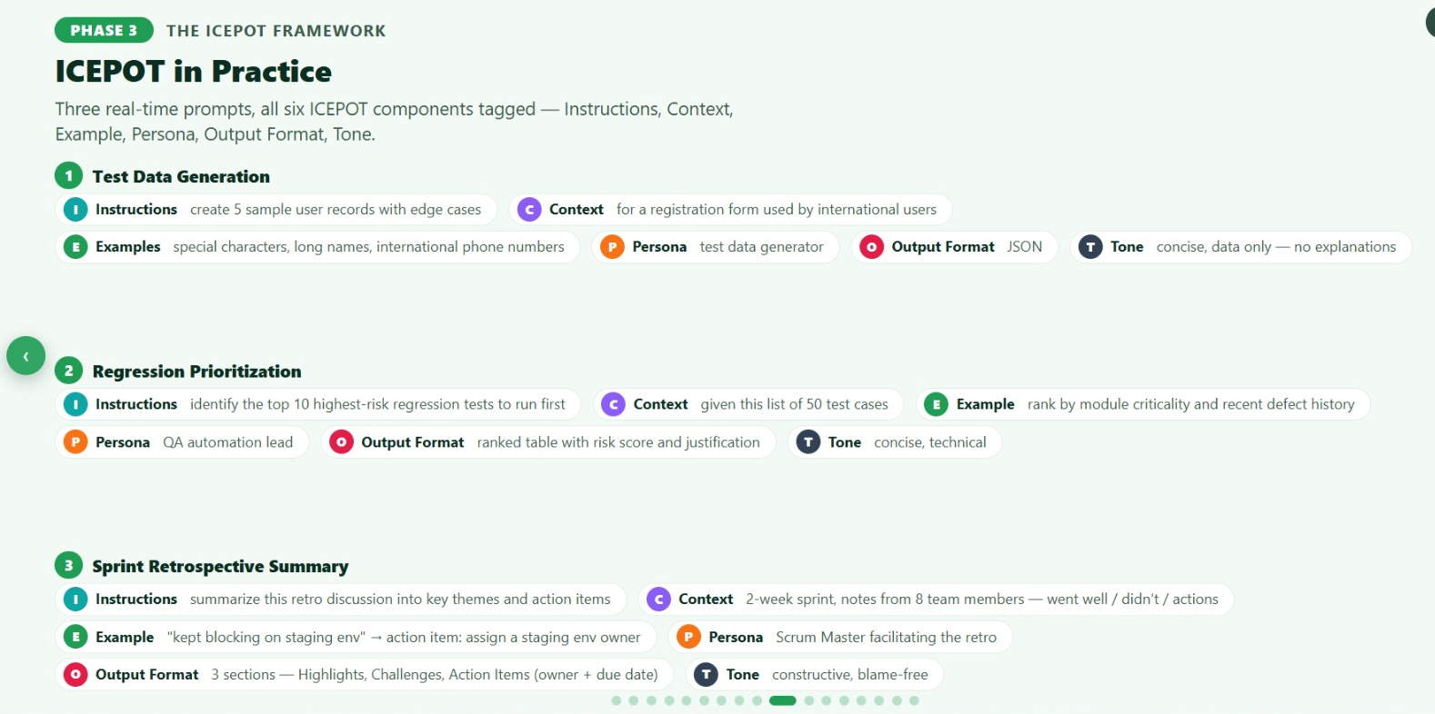
Extract:
PHASE 3 — THE ICEPOT FRAMEWORK
ICEPOT in Practice
Three real-time prompts, all six ICEPOT components tagged — Instructions, Context, Example, Persona, Output Format, Tone.
1. Test Data Generation
[
{
"username": "José_O'Connor",
"firstName": "José",
"lastName": "O'Connor",
"email": "jose.oconnor@example.com",
"phone": "+353871234567",
"country": "Ireland"
},
{
"username": "李明",
"firstName": "李",
"lastName": "明",
"email": "li.ming@example.cn",
"phone": "+8613812345678",
"country": "China"
},
{
"username": "Alexandria_Elizabeth_Montgomery-Smith",
"firstName": "Alexandria Elizabeth",
"lastName": "Montgomery-Smith",
"email": "alexandria.montgomery.smith@example.co.uk",
"phone": "+447911123456",
"country": "United Kingdom"
},
{
"username": "François-Dupont",
"firstName": "François",
"lastName": "Dupont",
"email": "francois.dupont+test@example.fr",
"phone": "+33612345678",
"country": "France"
},
{
"username": "Nour_Al-Hassan",
"firstName": "Nour",
"lastName": "Al-Hassan",
"email": "nour.alhassan@example.ae",
"phone": "+971501234567",
"country": "United Arab Emirates"
}
]

2. Regression Prioritization
Regression Prioritization — Top 10 Highest-Risk Tests
The source file provides recent defect counts but does not define an explicit module-criticality score. Therefore, the criticality assessment below is a QA Lead inference from the business impact described by each test case, while the defect-history component uses the supplied “last 2 releases” data.
Rank | TC ID | Module | Test Case | Recent Defects | Risk Score | Justification
1 | TC-022 | Payment | Payment gateway timeout handling | 3 | 10/10 | Payment is transaction-critical and this scenario has the highest recent defect count.
2 | TC-020 | Payment | Payment via credit card success | 2 | 9/10 | Core payment path with recent defects; failure directly affects successful order completion.
3 | TC-023 | Payment | Refund processed after order cancellation | 2 | 9/10 | Financial transaction flow with recent defects; refund correctness is business-critical.
4 | TC-016 | Checkout | Apply valid discount code | 2 | 8/10 | Checkout affects order completion, and the scenario has multiple recent defects.
5 | TC-019 | Checkout | Order summary matches cart before payment | 1 | 8/10 | Validates financial/order accuracy immediately before payment.
6 | TC-025 | Payment | Fund transfer between two same-bank accounts | 1 | 8/10 | Financial transaction scenario with recent defect history.
7 | TC-021 | Payment | Payment via credit card declined | 1 | 8/10 | Critical payment failure path with a recent defect.
8 | TC-028 | Order | Order status updates (placed → shipped → delivered) | 1 | 7/10 | Core order lifecycle with recent defects and multiple state transitions.
9 | TC-009 | Cart | Add multiple items to cart | 1 | 7/10 | Cart functionality feeds directly into checkout and has recent defect history.
10 | TC-033 | Search | Search with filters (category, price) | 2 | 7/10 | Highest recent defect count among Search scenarios; important product-discovery functionality.
Prioritization Basis
- Module criticality: inferred from the business function represented by the test case.
- Recent defect history: taken directly from the uploaded list for the last two releases.
- Risk score: combines business criticality and recent defect history; it is a prioritization aid rather than a source-provided metric.
- Execution order: Start with the payment/financial transaction paths, followed by checkout/order flows, then supporting customer-facing functionality.
The source also shows that other scenarios have recent defects—for example password reset, SSO, expired discount handling, partial refund, search sorting, notifications, and admin refund—but they fall outside the selected top 10 under the combined prioritization approach.
Home Assignment:

Prompthaton
Scenario 1:
Weak Prompt answer:
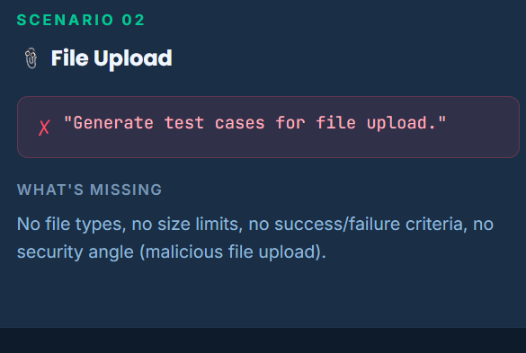
TC ID | Priority | Description | Precondition | Steps | Expected / Actual Result | Test Data
TC-FU-001 | P0 | Verify a valid file can be uploaded successfully | User is logged in and file upload feature is available | 1. Navigate to file upload2. Select a valid file3. Click Upload | Expected: File uploads successfully and success confirmation is displayed.Actual: To be captured during execution. | Valid file within supported size/type
TC-FU-002 | P0 | Verify upload is rejected for an unsupported file type | User is logged in and upload feature is available | 1. Open upload control2. Select an unsupported file3. Click Upload | Expected: File is rejected and an appropriate file-type validation message is displayed.Actual: To be captured during execution. | Unsupported file: .exe
TC-FU-003 | P0 | Verify upload is rejected when file size exceeds the configured limit | User is logged in; maximum file size is configured | 1. Open upload control2. Select a file larger than the allowed limit3. Click Upload | Expected: Upload is rejected and a file-size validation message is displayed.Actual: To be captured during execution. | File size: Above configured maximum
TC-FU-004 | P1 | Verify a file at the maximum permitted size can be uploaded | User is logged in; maximum file size is known | 1. Open upload control2. Select a file exactly at the maximum allowed size3. Click Upload | Expected: File uploads successfully if it meets all other validation rules.Actual: To be captured during execution. | File size: Configured maximum
TC-FU-005 | P1 | Verify upload is rejected when no file is selected | User is logged in and upload page is available | 1. Navigate to upload feature2. Do not select a file3. Click Upload | Expected: Upload is not initiated and a mandatory-file validation message is displayed.Actual: To be captured during execution. | File: None
TC-FU-006 | P1 | Verify multiple file upload when multiple files are supported | User is logged in and multiple-file upload is enabled | 1. Open upload control2. Select multiple valid files3. Click Upload | Expected: All valid files are uploaded successfully and each file is displayed in the uploaded-file list.Actual: To be captured during execution. | 2–3 valid supported files
TC-FU-007 | P1 | Verify duplicate file handling | A file with the same name/content already exists | 1. Upload a valid file2. Attempt to upload the same file again | Expected: System follows the defined duplicate-file rule, such as rejection, replacement, or renaming.Actual: To be captured during execution. | Existing file + duplicate file
TC-FU-008 | P2 | Verify cancellation before completing file selection | User is logged in and upload control is available | 1. Open file selection2. Select a file3. Cancel the selection/upload operation | Expected: Upload is cancelled and no unintended file is added.Actual: To be captured during execution. | Valid supported file
TC-FU-009 | P2 | Verify uploaded file can be removed | A valid file has already been uploaded | 1. Upload a valid file2. Select Remove/Delete for the uploaded file3. Confirm removal if prompted | Expected: File is removed from the uploaded-file list and is no longer associated with the record.Actual: To be captured during execution. | Previously uploaded valid file
TC-FU-010 | P2 | Verify file name with special characters is handled correctly | User is logged in; supported file type is selected | 1. Open upload control2. Select a supported file with special characters in its name3. Upload the file | Expected: System either accepts the file according to the defined filename rules or displays appropriate validation; no corrupted filename should be stored.Actual: To be captured during execution. | Test File_#01 (Final).pdf

Strong Prompt:
Instruction :
User uploading the file into CRM App
[Mandatory] only .csv file allowed
[Strictly] maximum size 15 Mb
Cover positive and negative scenarios
[Strictly] only 5 test cases

Context : Generate test cases for file upload process
Example :
Persona : As a Sales representative of Retail products
Output Format : table
Tone : Professional
TC ID | Priority | Test Scenario | Precondition | Test Steps | Expected Result | Test Data
TC-FU-001 | P0 | Upload a valid .csv file within the 15 MB limit | User is logged in to the CRM App and has access to file upload | 1. Navigate to the file upload screen.2. Select a valid .csv file.3. Ensure file size is ≤ 15 MB.4. Click Upload. | File is uploaded successfully and a confirmation message is displayed. | Valid .csv, 10 MB
TC-FU-002 | P1 | Reject a file with an unsupported extension | User is on the file upload screen | 1. Select a file with an extension other than .csv.2. Click Upload. | File upload is rejected and an appropriate file-format validation message is displayed. | .xlsx, 5 MB
TC-FU-003 | P0 | Reject a .csv file exceeding the 15 MB maximum size | User is on the file upload screen | 1. Select a valid .csv file larger than 15 MB.2. Click Upload. | File upload is rejected and a file-size validation message is displayed. | .csv, 15.1 MB
TC-FU-004 | P1 | Upload a .csv file exactly at the 15 MB limit | User is logged in and has access to file upload | 1. Select a valid .csv file of exactly 15 MB.2. Click Upload. | File is accepted and uploaded successfully because it meets the maximum allowed size. | .csv, 15 MB
TC-FU-005 | P2 | Attempt upload without selecting a file | User is on the file upload screen | 1. Do not select any file.2. Click Upload. | Upload is prevented and an appropriate required-file validation message is displayed. | No file

Scenario 2:
Weak
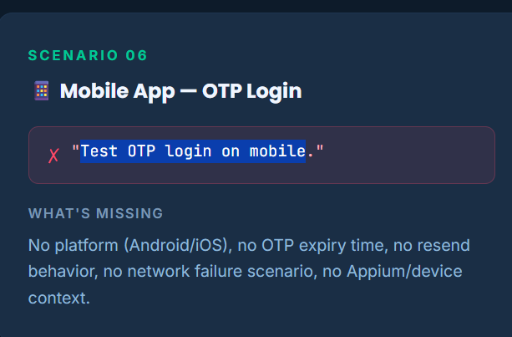
TC ID | Priority | Scenario | Precondition | Test Steps | Expected Result | Test Data
OTP-001 | P0 | Login with valid OTP | User is registered and OTP is generated | 1. Open mobile app2. Enter registered mobile number3. Request OTP4. Enter valid OTP5. Tap Login | User is successfully authenticated and navigated to the home/dashboard screen | Registered mobile: 9876543210Valid OTP: 123456
OTP-002 | P0 | Login with invalid OTP | OTP login screen is displayed | Enter an incorrect OTP and submit | Login is rejected and a clear validation message is displayed | OTP: 654321
OTP-003 | P1 | Login with expired OTP | OTP has exceeded its validity period | Enter expired OTP and submit | Login is rejected with an appropriate expired-OTP message | Expired OTP
OTP-004 | P1 | Resend OTP | User is on OTP verification screen | Tap Resend OTP | New OTP is generated and delivered; previous OTP becomes invalid if applicable | Registered mobile number
OTP-005 | P1 | OTP with incomplete digits | OTP screen is displayed | Enter fewer digits than required and submit | Login is blocked and OTP format validation is displayed | 1234
OTP-006 | P1 | OTP with non-numeric characters | OTP screen is displayed | Attempt to enter letters/special characters | Non-numeric characters are rejected or validation is displayed | 12AB@#
OTP-007 | P2 | Multiple incorrect OTP attempts | OTP verification is active | Enter incorrect OTP repeatedly until the attempt limit is reached | Further verification is blocked according to the security policy | Multiple invalid OTPs
OTP-008 | P2 | OTP login without entering mobile number | Login screen is displayed | Leave mobile number blank and request OTP | OTP request is prevented and required-field validation is displayed | Blank mobile number
OTP-009 | P2 | OTP autofill on mobile device | OTP is received on the device | Receive OTP and observe the OTP field | Supported mobile OS/device autofill populates the OTP correctly without exposing it improperly | Valid OTP
OTP-010 | P1 | OTP verification after app backgrounding | OTP has been requested | Send app to background, return to app, and enter OTP | OTP screen remains secure and verification behaves according to the session/OTP validity rules | Valid OTP

Strong:

Instruction :
Validate OTP verification on mobile for Money Transfer to others from my account
Cover positive and negative scenarios
Cover for iOS and Android
Include expiry time
Write for Android studio ,Sauce Labs emulators
[Strictly] only 8 test cases

Context : Generate test cases for validating OTP login on mobile
Example :
Persona : Mobile App User is Customer
Output Format : table
Tone : Professional
TC ID | Platform | Priority | Test Scenario | Precondition | Test Steps | Expected Result | Test Data
OTP-MT-001 | Android & iOS | P0 | Successful money transfer using a valid OTP within expiry time | Customer is logged in; valid beneficiary and sufficient balance are available; OTP validity is configured as 5 minutes | 1. Select Money Transfer to Others.2. Enter valid beneficiary and amount.3. Submit transfer.4. Enter the valid OTP within 5 minutes.5. Tap Verify/Confirm. | OTP is verified successfully and the money transfer is completed. Transaction confirmation is displayed. | Valid OTP; expiry: 5 min; Sauce Labs Android/iOS emulator
OTP-MT-002 | Android & iOS | P0 | Reject transfer when an invalid OTP is entered | OTP verification screen is displayed | 1. Initiate a valid money transfer.2. Enter an incorrect OTP.3. Tap Verify/Confirm. | OTP verification fails, an appropriate error message is displayed, and the transfer is not completed. | Invalid OTP; Sauce Labs Android/iOS emulator
OTP-MT-003 | Android & iOS | P0 | Reject expired OTP after the configured expiry time | OTP has been generated; OTP validity is 5 minutes | 1. Initiate money transfer.2. Wait until 5-minute OTP validity expires.3. Enter the expired OTP.4. Tap Verify/Confirm. | OTP is rejected as expired and the money transfer is not completed. User is prompted to request a new OTP. | Expired OTP; 5-minute expiry
OTP-MT-004 | Android & iOS | P1 | Successfully verify transfer using a newly generated OTP after resend | Existing OTP is available and OTP verification screen is displayed | 1. Initiate transfer.2. Tap Resend OTP before/after the original OTP expires.3. Enter the newly received OTP within 5 minutes.4. Tap Verify/Confirm. | New OTP is accepted and the money transfer proceeds successfully. | New valid OTP; expiry: 5 min
OTP-MT-005 | Android & iOS | P1 | Reject previously generated OTP after a new OTP is requested | Customer has requested a new OTP | 1. Initiate transfer and capture the first OTP.2. Tap Resend OTP.3. Enter the previous OTP.4. Tap Verify/Confirm. | Previous OTP is rejected and the transfer is not completed. | Old OTP + newly generated OTP
OTP-MT-006 | Android & iOS | P1 | Prevent verification after maximum invalid OTP attempts | OTP verification screen is displayed and maximum-attempt policy is configured | 1. Initiate transfer.2. Enter an invalid OTP repeatedly until the configured attempt limit is reached.3. Submit each attempt. | OTP verification is blocked after the maximum permitted attempts and the transfer remains unprocessed. | Invalid OTPs; configured attempt limit
OTP-MT-007 | Android & iOS | P2 | Validate OTP submission with fewer digits than required | OTP verification screen is displayed | 1. Initiate transfer.2. Enter an incomplete OTP.3. Tap Verify/Confirm. | OTP format validation is displayed and the transfer is not processed. | Incomplete OTP, e.g. 1234 for a 6-digit OTP
OTP-MT-008 | Android & iOS | P2 | Validate OTP verification after app is backgrounded during the expiry window | Customer is on the OTP verification screen with a valid OTP | 1. Initiate money transfer.2. Send the app to the background.3. Return to the app before OTP expiry.4. Enter the valid OTP.5. Tap Verify/Confirm. | If OTP is still within its 5-minute validity window, it is verified and the transfer completes; otherwise, the OTP is rejected as expired. | Valid/expired OTP; 5-minute expiry; Sauce Labs Android & iOS emulators

Scenario:3
Weak
Generate Test the reports section
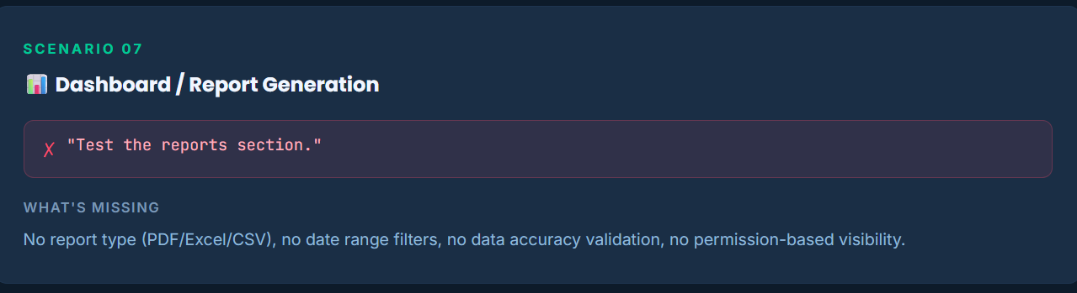
TC ID | Priority | Test Scenario | Precondition | Test Steps | Expected Result | Test Data
REP-001 | P0 | Generate report with valid criteria | User has access to the Reports section | 1. Navigate to Reports.2. Select a valid report type.3. Enter valid date/filter criteria.4. Click Generate. | Report is generated successfully and displays data matching the selected criteria. | Valid report type, date range
REP-002 | P0 | Verify report data accuracy | A report has been generated | 1. Generate a report.2. Compare displayed records with the corresponding source/transaction data. | Report records, totals, dates, and relevant fields match the underlying data. | Existing transaction records
REP-003 | P1 | Generate report using different filter combinations | User has access to Reports | 1. Select different available filters.2. Apply filters.3. Generate the report. | Report displays only records matching all selected filter criteria. | Multiple valid filter combinations
REP-004 | P1 | Validate report for a date range with no data | User has access to Reports | 1. Select a valid date range containing no records.2. Generate the report. | System displays an appropriate No Data Available message without errors. | Date range with no records
REP-005 | P1 | Export generated report | A report has been generated successfully | 1. Generate a report.2. Select the available export option.3. Download the report.4. Open the downloaded file. | Report is downloaded successfully and exported data matches the generated report. | Valid generated report
REP-006 | P1 | Validate mandatory report criteria | Reports section requires report criteria | 1. Open Reports.2. Leave mandatory fields blank.3. Click Generate. | Report generation is prevented and appropriate validation messages are displayed. | Blank mandatory fields
REP-007 | P2 | Verify report access for unauthorized user | User does not have permission to access Reports | 1. Log in as an unauthorized user.2. Attempt to access Reports directly or through navigation. | Reports access is denied and the user cannot view restricted report data. | Unauthorized user
REP-008 | P1 | Handle report generation failure | Reports service/system is unavailable or encounters an error | 1. Open Reports.2. Enter valid criteria.3. Click Generate while the service is unavailable. | System displays a clear error message and does not show incomplete or misleading report data. | Valid criteria; simulated service failure

Strong:
Instruction :
Generate Monthly sales report for Walmart from June 01-June 30
[Mandatory] Pennsylvania state report
Include both Online and Offline sales
[Strictly] only 8 test cases

Context : Generate Report for Monthly sales for Walmart
Example :
Persona : Sales associate
Output Format : table
Tone : Professional
TC ID | Priority | Test Scenario | Precondition | Test Steps | Expected Result | Test Data
REP-WMT-001 | P0 | Generate monthly Walmart sales report for Pennsylvania | Sales associate has Reports access | 1. Open Reports.2. Select Walmart.3. Select Pennsylvania.4. Set date range to June 01–June 30.5. Select Monthly Sales Report.6. Click Generate. | Report is generated successfully for Walmart sales in Pennsylvania covering exactly June 01 through June 30. | Walmart; Pennsylvania; June 01–June 30
REP-WMT-002 | P0 | Verify Online sales are included in the report | Walmart Pennsylvania monthly report is generated | 1. Generate the report for June 01–June 30.2. Review the Online Sales section/data.3. Compare with source sales records. | All eligible Walmart Pennsylvania Online sales within the specified date range are included accurately. | Sales Channel: Online
REP-WMT-003 | P0 | Verify Offline sales are included in the report | Walmart Pennsylvania monthly report is generated | 1. Generate the report for June 01–June 30.2. Review the Offline Sales section/data.3. Compare with source sales records. | All eligible Walmart Pennsylvania Offline sales within the specified date range are included accurately. | Sales Channel: Offline
REP-WMT-004 | P0 | Verify combined Online and Offline sales totals | Online and Offline sales records exist for the selected period | 1. Generate the report.2. Note Online sales total.3. Note Offline sales total.4. Verify the overall sales total. | Overall sales total correctly represents the combined eligible Online and Offline sales for Walmart Pennsylvania during June 01–June 30. | Online + Offline sales
REP-WMT-005 | P1 | Verify sales outside June 01–June 30 are excluded | Sales records exist before June 01 and after June 30 | 1. Generate the June monthly report.2. Review report records and totals. | Sales dated before June 01 or after June 30 are excluded from the report. | Boundary dates: May 31; July 01
REP-WMT-006 | P1 | Verify sales from states other than Pennsylvania are excluded | Walmart has sales records across multiple states | 1. Generate the report with Pennsylvania selected.2. Review sales records and totals. | Only Walmart sales associated with Pennsylvania are included; other states are excluded. | State: Pennsylvania; other states
REP-WMT-007 | P1 | Verify report when no Walmart Pennsylvania sales exist | No eligible Walmart Pennsylvania sales exist for the selected June period | 1. Select Walmart and Pennsylvania.2. Set date range to June 01–June 30.3. Generate the report. | System displays an appropriate No Sales Data/No Records Found message and does not display misleading totals. | No eligible sales
REP-WMT-008 | P2 | Export the generated monthly sales report | Walmart Pennsylvania June report has been generated | 1. Generate the report.2. Select the available Export/Download option.3. Open the exported report.4. Verify Online, Offline, state, date range, and totals. | Report is exported successfully and contains the same Walmart Pennsylvania June 01–June 30 sales data and totals as the generated report. | Walmart; Pennsylvania; June 01–June 30; Online + Offline

Week 2 Day 2 Home assignments

Assignment 1
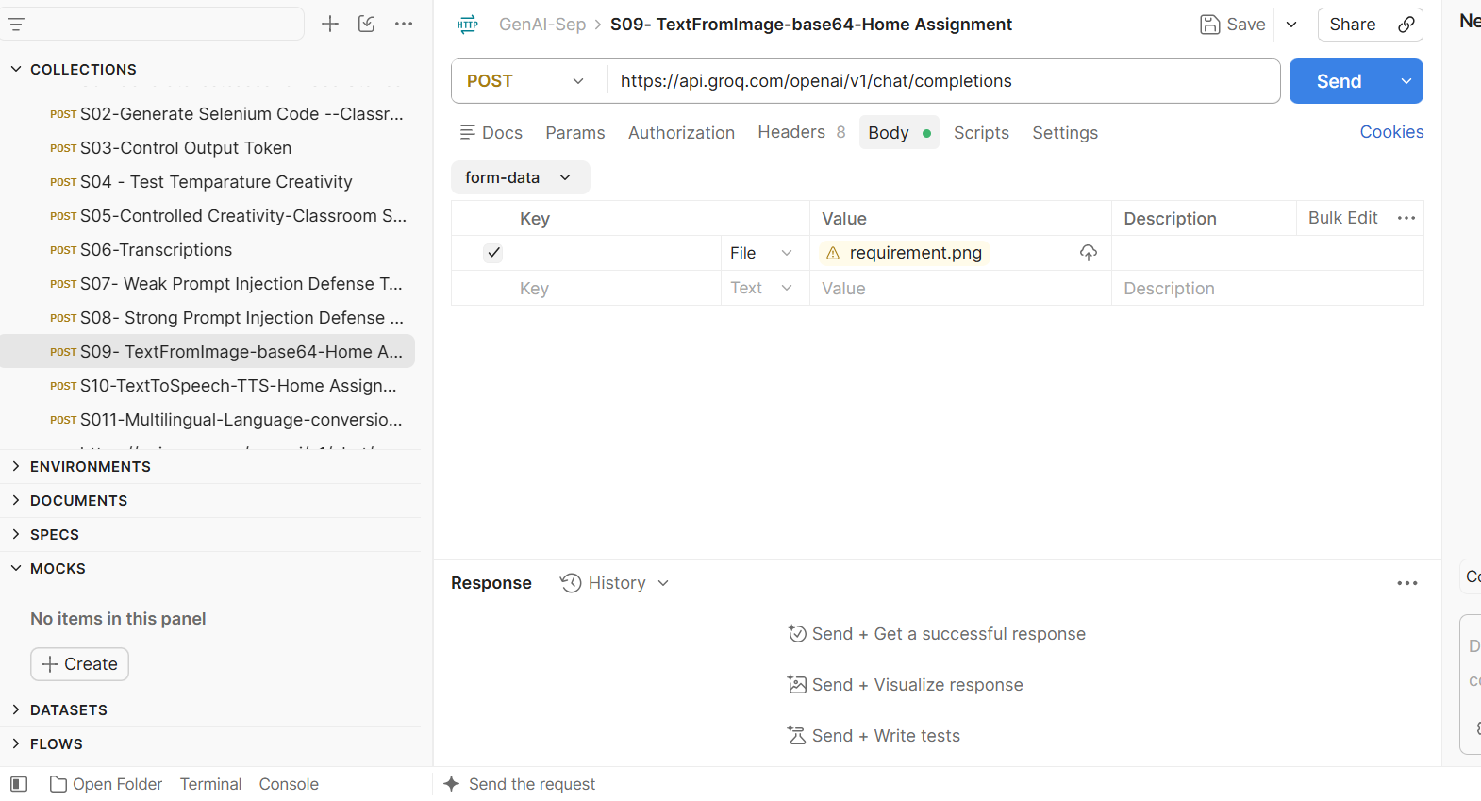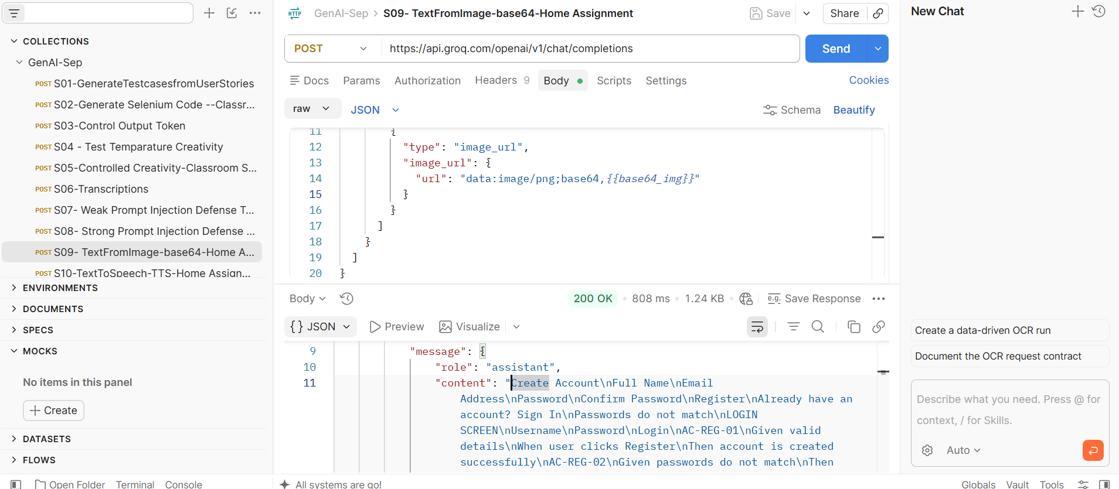
Field | Details
Screen | Create Account
Fields | Full Name, Email Address, Password, Confirm Password
Action | Register
Existing Account | Already have an account? Sign In
Validation Message | Passwords do not match
Field | Details
Screen | LOGIN SCREEN
Fields | Username, Password
Action | Login
Acceptance Criteria
AC-REG-01 – Successful Registration
Given valid registration details are entered
When the user clicks Register
Then the account is created successfully.
AC-REG-02 – Password Mismatch
Given the Password and Confirm Password values do not match
When the user attempts to register
Then an error message “Passwords do not match” is displayed.
Acceptance Criteria
AC-LOGIN-01 – Successful Login
Given a valid username and password are entered
When the user clicks Login
Then the user is logged in successfully.
AC-LOGIN-02 – Invalid Credentials
Given an invalid username or password is entered
When the user clicks Login
Then an error message is displayed.

Assignment 2
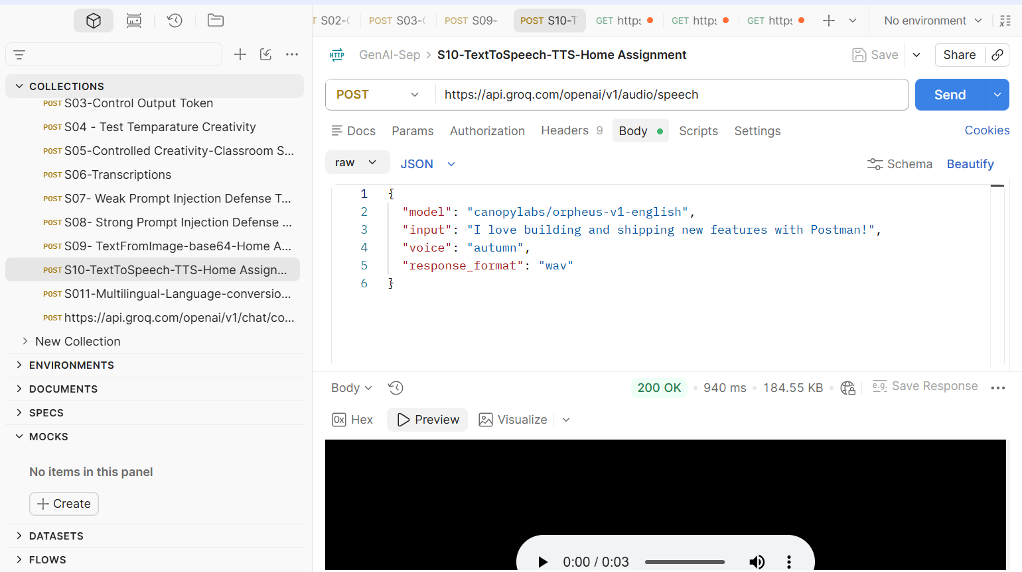

Assignment 3
